Firmware C19/C21 Verification Test Specification

Edition | Date | Issued by | Comments
0.1 | 2010-05-05 | CNAUS/Ye-Ye Zhang | Proposal Draft

TABLE OF CONTENTS

1. GENERAL 3
1.1 References 3
1.2 Definitions 3
1.3 Abbreviations 3
1.4 Test object 3
2. Requirements 4
2.1 Simulation mode 4
2.2 Design margin tests, fault tolerance 4
2.3 Test environment setup 4
3. Unit test cases 10
3.1 PU 10
3.2 GPIO 12
3.3 ADC 13
3.4 Inverter 16
3.5 PWM 20
3.6 Rectifier Controller 22

GENERAL
This document contains the Verification Test Specification (VTS) for the FPGA C19/C21 on the power unit control board.

All the test cases are necessary to verify the function of the FPGA in simulation mode.

References
[1] 3HACxxxxxx-xxx DSQCxxx Technical Requirement Specification
[2] 3HACxxxxxx-xxx DSQCxxx FPGA Implementation Specification
[3] 3HAC030434-001 Implementation Specification of Rectifier Controller in Mink FPGA R19

Definitions
The following definitions are stated for this document:

VHDL Test bench
The test bench generated based on VHDL for simulation and checking if the module output have correct values. The result is presented OK or ERROR in a log file named result.log located in the simulation directory.

Abbreviations
Abbreviation | Description
FPGA | Field Programmable Gate Array
PU | Power Unit
I/O | In / Out
IP | Intellectual Property
CRC | Cyclic Redundancy Checking
FIFO | First In First Out(memory)
EEPROM | Electrically Erasable Programmable Read-Only Memory
SPI | Serial Peripheral Interface
ADC | Analog to Digital Converter
PWM | Pulse-Width Modulation

Test object
The following test object and software was used for the FPGA:

Test object
Device name | XC3S1600E-4
Supplier | Xilinx
Package | FG-320

Software
Development tools | Xilinx ISE 10.1i
Simulation tool | Mentor Graphic ModelSim XE III 6.3c

Requirements

Simulation mode
The simulation shall be in timing mode with 25 MHz clock on system clock (ref_clk).

Design margin tests, fault tolerance
Decrease and increase the clock frequency(25MHz) in the test benches to see when the tests fail.
Decrease and increase the baud rate (1Mbit/s) and duty cycle (50%) of the Ring Controller in the test benches to see when the tests fail.
The maximum supported frequency for the system should be 10% bigger than the real clock, which means the maximum value should be bigger than 110MHz (the real clock will be 100MHz for the general logic, except the EtherCAT IP).

Test environment setup
The test environment is based on the VHDL test bench.

According to the design, the EtherCAT and DCM IP cores are provided by third-part suppliers (Beckhoff and Xilinx), which have already been verified and don’t need to be tested again. As a result, this document mainly focuses on the verification for the other logic parts, as seen in Figure 1(the light colour blocks in the round).

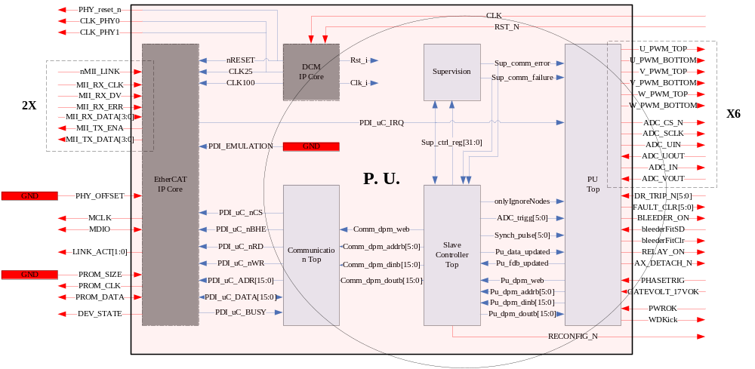
Figure 1 The Block Needs to Be Tested

The test environment is setup for the whole logic parts need to be tested in Figure 1. It is based on two parts: EtherCAT Simulator and Power Board Simulator, as Figure 2.

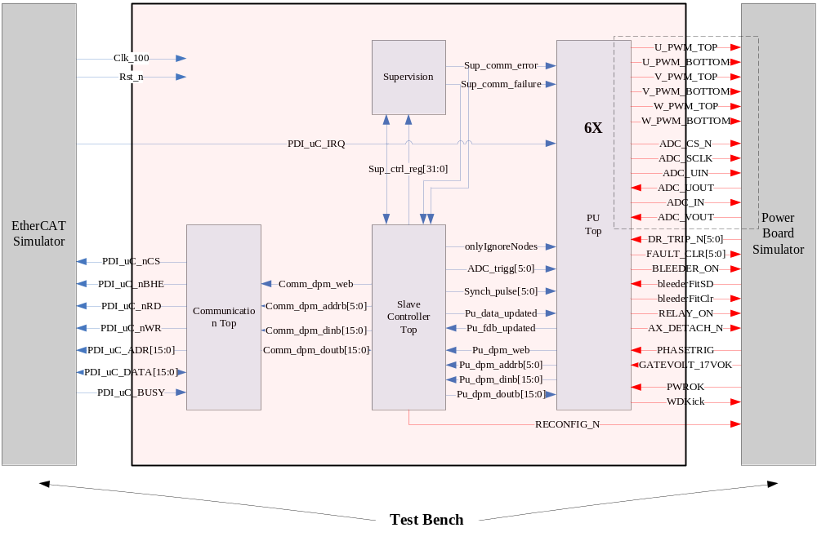
Figure 2 The Test Bench Setup for the Whole Target Unit

For the EtherCAT Simulator, it has one file to input data like EtherCAT input frame, and another file to output data like EtherCAT output frame. The input file will be read by “File Access Control” and put into DPRAM which is ready for the target unit to access. At the same time, The “File Access Control” generates a interrupt named “PDI_uC_IRQ” to start the target unit. The target unit will access the DPRAM through PDI, process the data and feedback the result, which can be read by “File Access Control” from DPRAM and written into the output file, as Figure 3.

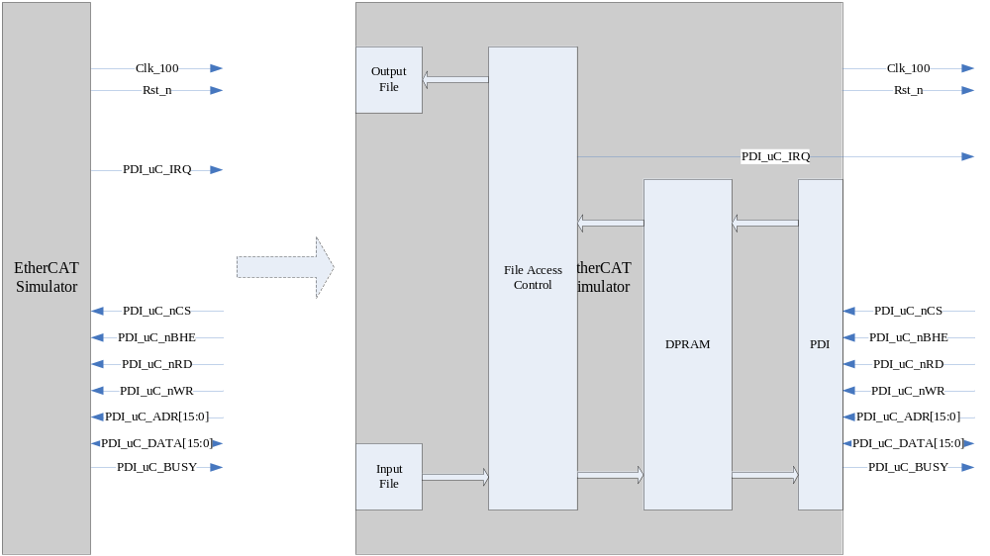
Figure 3 The EtherCAT Simulator Implementation

Table 1 shows the memory map in EtherCAT Simulator, it includes the control/status registers and input/output data.

Table 1 Memory Map in EtherCAT Simulator
Type | Name | Address
Registers | DL_Status | 0x0110
Registers | AL_Control | 0x0120
Registers | AL_Status | 0x0130
Registers | AL_Status_Code | 0x0134
Registers | AL_Event_Request | 0x0220
Registers | Watchdog_Status_Process_Data | 0x0440
Registers | SyncManager[0] | 0x0800 – 0x0807
Registers | SyncManager[1] | 0x0808 – 0x080F
Registers | SyncManager[2] | 0x0810 – 0x0817
Registers | SyncManager[3] | 0x0818 – 0x081F
Output data  (from EtherCAT Simulator to the target unit) | RefPad & CRC8 | 0x1100
Output data  (from EtherCAT Simulator to the target unit) | UnitCmd | 0x1102
Output data  (from EtherCAT Simulator to the target unit) | MaxLostFrames | 0x1104
Output data  (from EtherCAT Simulator to the target unit) | NodeCmd | 0x1106
Output data  (from EtherCAT Simulator to the target unit) | PWMDelayTime | 0x1108
Output data  (from EtherCAT Simulator to the target unit) | UaTurnOn | 0x110A
Output data  (from EtherCAT Simulator to the target unit) | UbTurnOn | 0x110C
Output data  (from EtherCAT Simulator to the target unit) | UcTurnOn | 0x110E
Output data  (from EtherCAT Simulator to the target unit) | NodeCmd | 0x1110
Output data  (from EtherCAT Simulator to the target unit) | PWMDelayTime | 0x1112
Output data  (from EtherCAT Simulator to the target unit) | UaTurnOn | 0x1114
Output data  (from EtherCAT Simulator to the target unit) | UbTurnOn | 0x1116
Output data  (from EtherCAT Simulator to the target unit) | UcTurnOn | 0x1118
Output data  (from EtherCAT Simulator to the target unit) | NodeCmd | 0x111A
Output data  (from EtherCAT Simulator to the target unit) | PWMDelayTime | 0x111C
Output data  (from EtherCAT Simulator to the target unit) | UaTurnOn | 0x111E
Output data  (from EtherCAT Simulator to the target unit) | UbTurnOn | 0x1120
Output data  (from EtherCAT Simulator to the target unit) | UcTurnOn | 0x1122
Output data  (from EtherCAT Simulator to the target unit) | BleederTurnOn | 0x1124
Output data  (from EtherCAT Simulator to the target unit) | MaxIncommingMains | 0x1126
Output data  (from EtherCAT Simulator to the target unit) | Pad | 0x1128
Input data  (from the target unit to EtherCAT Simulator) | FdbPad & CRC8 | 0x1300
Input data  (from the target unit to EtherCAT Simulator) | UnitStatus | 0x1302
Input data  (from the target unit to EtherCAT Simulator) | DCVolts | 0x1304
Input data  (from the target unit to EtherCAT Simulator) | NodeStatus | 0x1306
Input data  (from the target unit to EtherCAT Simulator) | PAD | 0x1308
Input data  (from the target unit to EtherCAT Simulator) | UPhaseCurrent | 0x130A
Input data  (from the target unit to EtherCAT Simulator) | VPhaseCurrent | 0x130C
Input data  (from the target unit to EtherCAT Simulator) | IGBT Temp | 0x130E
Input data  (from the target unit to EtherCAT Simulator) | NodeStatus | 0x1310
Input data  (from the target unit to EtherCAT Simulator) | PAD | 0x1312
Input data  (from the target unit to EtherCAT Simulator) | UPhaseCurrent | 0x1314
Input data  (from the target unit to EtherCAT Simulator) | VPhaseCurrent | 0x1316
Input data  (from the target unit to EtherCAT Simulator) | IGBT Temp | 0x1318
Input data  (from the target unit to EtherCAT Simulator) | NodeStatus | 0x131A
Input data  (from the target unit to EtherCAT Simulator) | PAD | 0x131C
Input data  (from the target unit to EtherCAT Simulator) | UPhaseCurrent | 0x131E
Input data  (from the target unit to EtherCAT Simulator) | VPhaseCurrent | 0x1320
Input data  (from the target unit to EtherCAT Simulator) | IGBT Temp | 0x1322
Input data  (from the target unit to EtherCAT Simulator) | RectifierStatus | 0x1324
Input data  (from the target unit to EtherCAT Simulator) | RectifierTemp | 0x1326
Input data  (from the target unit to EtherCAT Simulator) | PAD | 0x1328

The input text file is generated by a Microsoft Excel application. Inside the Excel application is a model that describes the connection between the input parameters of the Excel application and the values in the input text file. This model is used to generate a file that contains the expected values of the input text file.A snippet from the Excel application is shown in Figure 4. All white cells are parameters. The colored cells contain values generated during execution of the application.
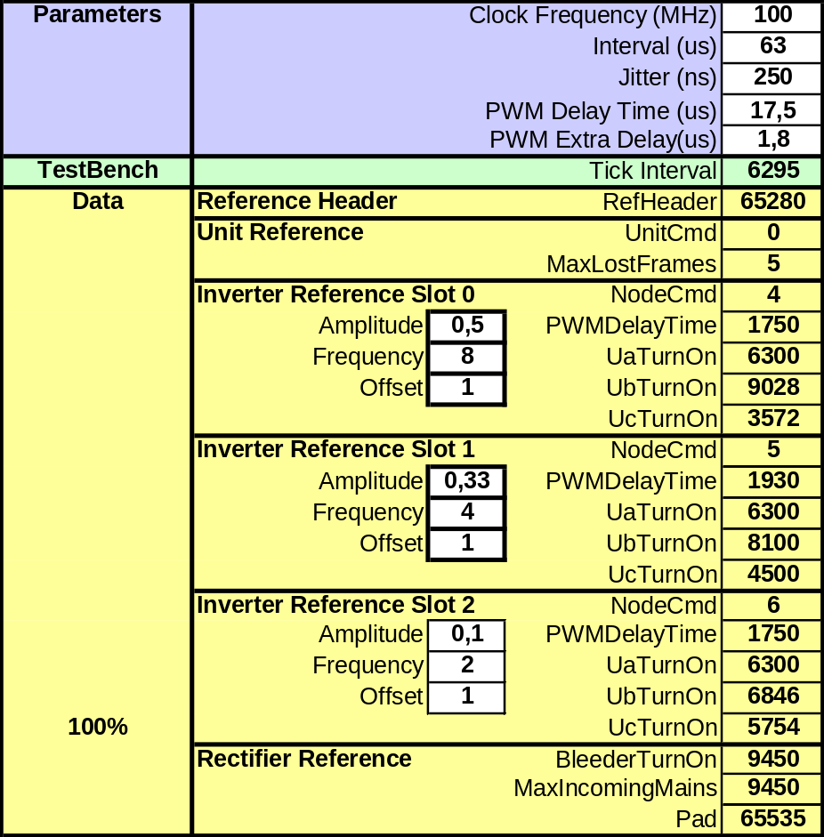

Figure 4 Snippet of the Excel Application

For the Power Board Simulator, it also has two files, one for input and the other for output.
The input file stores the values for the target unit input I/O signals and ADC simulator. The output file will save the results for the target unit output I/O signals, as Figure 4.

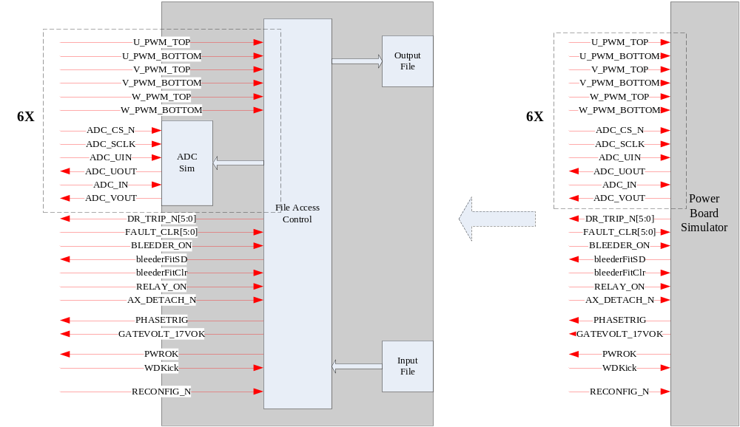
Figure 5 The Power Board Simulator Implementation

This document describes the firmware implementation of the FPGA on the Power Unit Control Board, which could be located onto MDU/ARU/ADU. In the Robot Drive control system, the FPGA on the Control Board is used to control the drive of Power Unit.

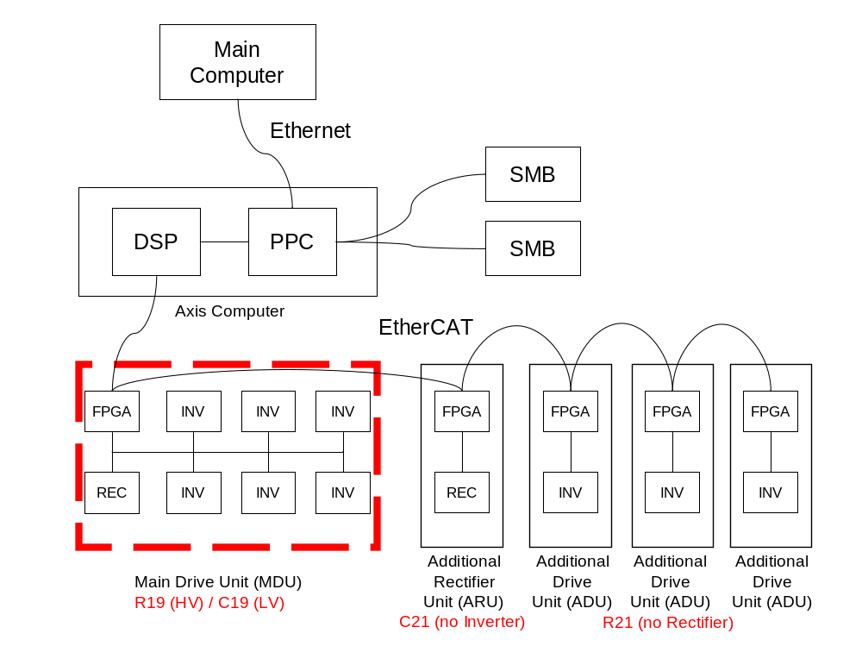
Fig 1 Robot Drive Control System

The FPGA controls the Rectifier on the MDU/ARU. Meanwhile it generates the PWM-sequence to the inverters and samples the motor currents on the MDU/ADU.

The firmware in FPGA is comprised of several modules, including Communication part, application related Slave Controller, Power Unit drive, etc. An EtherCAT slave is implemented in the FPGA which is used to communicate between the Axis Computer and MDU, and to send on data to/from the ARU.

Unit test cases

PU
Test | 1 | Reference Data Updated with Invalid Frame
Name |  | Address Decoder UC 1 | Block | PU_top.vhd
Requirement |  | The activeNodes are also updated if the incoming frame is invalid. In this case the node numbers for the previous communication cycle is reused, and this reuses switching between old node numbers until it is no longer safe to control the PWM with old values.
Test Setup |  | Set pu_data_updated as 1;  Set validFrame as 0;  Set node_numA_d as 0b000;  Set node_numB_d as 0b001;  Set node_numC_d as 0b011;  Set node_numA as 0b100;  Set node_numB as 0b110;  Set node_numC as 0b111.
Expected Result |  | Check address_decoder_state as Idle, Upd_NodeNr, Upd_ValidNodes, and Idle for the first loop;  Check validNodeA as 0;  Check validNodeB as 1;  Check validNodeC as 1;  Check activeNodes as 0b000110;  Check address_decoder_state as Idle, Upd_NodeNr, Upd_ValidNodes, and Idle for the second loop;  Check validNodeA as 1;  Check validNodeB as 1;  Check validNodeC as 0;  Check activeNodes as 0b011000.

Test | 2 | Reference Data Updated with Valid Frame
Name |  | Address Decoder UC 2 | Block | PU_top.vhd
Requirement |  | The Address Decoder starts to copy from SC to PU when new reference data has been received. It reads the data from the SC DPM in terms of steps from 0 to 17. Note that, two states after the DPM has been addressed, the data is available.
Test Setup |  | Set pu_data_updated as 1;  Set validFrame as 1;  Set NODE_CMD_1 as 0x0000;  Set NODE_CMD_2 as 0x0002;  Set NODE_CMD_3 as 0x0004;  Set swTimePhaseU as …;  Set swTimePhaseV as …;  Set swTimePhaseW as …;  Set pwmDelayTime as ….
Expected Result |  | Check address_decoder_state as Idle, Copy_SCtoPU, Upd_ActiveNodes, and Idle;  Check nr_of_reads as 0 to 17;  Check pwmOn as 0b000000;  Check pwmSwFreq as 0b000000;  Check resetInverterFailure as 0b000000;  Check validNodeA as 0;  Check validNodeB as 1;  Check validNodeC as 1;  Check swTimePhaseU as …;  Check swTimePhaseV as …;  Check swTimePhaseW as …;  Check pwmDelayTime as …;  Check activeNodes as 0b001010.

Test | 3 | Feedback Data Updated
Name |  | Address Decoder UC 3 | Block | PU_top.vhd
Requirement |  | The Address Decoder starts to copy from PU to SC when ADC block has updated the feedback data. When the data was read from the PU DPM or registers during previous cycle, it is written to the SC DPM in terms of steps from 0 to 14.
Test Setup |  | Set pu_data_updated as 0;  Set copyTrig as 1;  Set iPhaseU as …;  Set iPhaseV as …;  Set IGBTTemp as …;  Set DC_V as 0x0007;  Set rectCtrlFbkData as 0x0008;  Set rectTemp as 0x0009.
Expected Result |  | Check address_decoder_state as Idle, Copy_PUtoSC, and Idle;  Check nr_of_reads as 0 to 14;  Check pwmOn as 0b000000;  Check pwmSwFreq as 0b000000;  Check resetInverterFailure as 0b000000;  Check iPhaseU as …;  Check iPhaseV as …;  Check IGBTTemp as …;  Check DC_V as 0x0007;  Check rectCtrlFbkData as 0x0008;  Check rectTemp as 0x0009;  Check NODE_STATUS as ….

Test | 4 | Conventional Inverter-trigg and ADC-trigg Timing
Name |  | Trigg Generator UC 1 | Block | PU_top.vhd
Requirement |  | The PWMDelayTime parameter for each node is compared with ticksSinceEvent counter and a trig pulse for each inverter is generated. There are also ADC-trigg pulses for each node generated. They are the same as Inverter-trigg pulses, but they advance ADJUSTING_SAMPLE in order to sample the ADC in the centre of PWM.
Test Setup |  | Set puTrigg as 0;  Set puErrorTrigg as 0;  Set activeNodes as …;  Set PWMDelayTime as …;  Set comm_failure as 0;  Set periodStarted as 1;  Set puTrigg as 1 for 10 ns.
Expected Result |  | Check inverterTrigg as …;  Check adcTrigg as ….

Test | 5 | Inverter-trigg and ADC-trigg Timing with Lost Frame
Name |  | Trigg Generator UC 2 | Block | PU_top.vhd
Requirement |  | The counter ticksSinceEvent is adjusted depending on which type of event that has occurred. If it was an ordinary incoming pdi_irq, the counter is set to PDI_IRQ_TO_PUTRIGG. Because it takes 8.5us from an incoming pdi_irq until a puTrigg pulse is generated to PU top by Slave Controller. If the event is a lost frame, the counter is set to wdtTimeout which is one of the parameters that are configured by the ECM during the slave application configuration.
Test Setup |  | Set puTrigg as 0;  Set puErrorTrigg as 0;  Set activeNodes as …;  Set PWMDelayTime as …;  Set comm_failure as 0;  Set periodStarted as 1;  Set wdtTimeout as …;  Set puErrorTrigg as 1 for 10 ns.
Expected Result |  | Check inverterTrigg as …;  Check adcTrigg as ….

Test | 6 | ADC-trigg Inactive Cycling Mechanism
Name |  | Trigg Generator UC 3 | Block | PU_top.vhd
Requirement |  | The signal vector ActiveNodes will activate Inverter-trigg and ADC-trigg for each node. And if a node is not active in either this or previous communication cycle, the specific node will have an ADC-trigg every communication cycle at DEFAULT_DELAY_TIME after pdi_irq.
Test Setup |  | Set puTrigg as 0;  Set puErrorTrigg as 0;  Set activeNodes as …;  Set periodStarted as 1;  Set wdtTimeout as …;  Set puErrorTrigg as 1 for 10 ns.
Expected Result |  | Check adcTrigg as ….

Test | 7 | Copy Data from PU top to SC DPM
Name |  | Trigg Generator UC 4 | Block | PU_top.vhd
Requirement |  | The signal copyTrig is also generated by this process. This signal indicates that the feedback data is about to be copied from the PU top to the SC DPM. The START_COPY is set to 3500 ticks. This means that 35us after pdi_irq is set, feedback data will start to be copied from PU top to SC DPM.
Test Setup |  | Set puTrigg as 0;  Set puErrorTrigg as 0;  Set periodStarted as 1;  Set puTrigg as 1 for 10 ns.
Expected Result |  | Check copyTrig as …;  Check periodStarted_d as ….

GPIO
Test | 1 | Axis Detach and Power Board Supply Supervision
Name |  | GPIO UC 1 | Block | GPIO_TOP.vhd
Requirement |  | The signal AX_DETACH_N in will be active on internal reset. And signal powerBoardSupplyFail will occur when power board voltage is abnormal.
Test Setup |  | Set PWROK as 1;  Set PLUS_18UVL0 as 1;  Set PWROK as 0 for 64 us;  Set PLUS_18UVL0 as 0 for 64 us.
Expected Result |  | Check AX_DETACH_N as 0 for 10 ns;  Check powerBoardSupplyFail as 1 for 10 ns.

Test | 2 | External Watchdog Kick
Name |  | GPIO UC 2 | Block | GPIO_TOP.vhd
Requirement |  | The process ExtWatchdog generates the watchdog kick, signal WDKick, which is 50% high. An external watchdog has been implemented to safeguard that the gatedriver circuits turns off the IGBTs if the FPGA clock would malfunction. The watchdog kick signal is 50kHz with 50% duty ratio.
Test Setup |  | NULL.
Expected Result |  | Check WDKick as 0 or 1 for 10 us each.

Test | 3 | Median Filter
Name |  | GPIO UC 3 | Block | medianFilter_ea.vhd
Requirement |  | The purpose of the median filter is to suppress glitches. The input signal is clocked nrOfFlipFlop times. Only odd numbers for nrOfFlipFlop must be used and specifies the filter length. Here, nrOfFlipFlop is 5. If three or more flipflop outputs are ‘1’, the median filter output is ‘1’, otherwise the median filter output is ‘0’.
Test Setup |  | Set PWROK as …;  Set GATEVOLT_17VOK as ….
Expected Result |  | Check PWROK_i1 as …;  Check PLUS_18UVL0_i1 as ….

Test | 4 | Low Pass Filter
Name |  | GPIO UC 4 | Block | lowPassFilter_rtl_ea.vhd
Requirement |  | The purpose of the low pass filter is to suppress high frequent disturbances.Three generics are utlized: decimationFactor, here is 100; setRstPolarity, here is low; filterLength, here is 64.
Test Setup |  | Set PWROK_i1 as …;  Set PLUS_18UVL0_i1 as ….
Expected Result |  | Check PWROK_i2 as …;  Check PLUS_18UVL0_i2 as ….

ADC
Test | 1 | Signals Rising Edge
Name |  | ADC UC 1 | Block | ADC_SH_CTRL.vhd
Requirement |  | The signal sync_trig_en is the rising edge of signal sync_trig, the signal conversion_ready_pos is generated on positive flank of signal conversion_ready.
Test Setup |  | Set sync_trig as 0;  Set conversion_ready as 0;  Set sync_trig as 1;  Set conversion_ready as 1.
Expected Result |  | Check sync_trig_en as 1 for 10 ns;  Check conversion_ready_pos as 1 for 10 ns.

Test | 2 | ADC Synchronized Sampling
Name |  | ADC UC 2 | Block | ADC_SH_CTRL.vhd
Requirement |  | The ADC sampling is synchronized and started when the sync pulse for the specific node comes from PU top. The ADC block for each node controls two ADC devices, totally four ADC channels. The addressing and reading out of ADC values are done for both ADC devices at the same time to get a simultaneous sampling of U-phase and V-phase currents.
Test Setup |  | Set sync_trig as 0;  Set conversion_ready as 0;  Set sync_trig as 1 for 100 ns;  Set conversion_ready as 1 for 100 ns;  Set conversion_ready as 0 for 1 us;  Set conversion_ready as 1 for 100 ns;  Set conv_data_uout as …;  Set conv_data_vout as ….
Expected Result |  | Check state as wait_for_sync, ch0, ch0_done, ch1, ch1_done, and wait_for_sync;  Check start_conversion as 1 for … ns;  Check adcCh as 1 for … ns, 0 for … ns and repeated;  Check data_out_u0 as …;  Check data_out_v0 as …;  Check data_out_u1 as …;  Check data_out_v1 as ….

Test | 3 | Signals Rising Edge
Name |  | ADC UC 3 | Block | ADC_SH_CTRL.vhd
Requirement |  | The ADC clock pace generation process should generates a clock pace for the ADC. The 3 bit counter clk_en_counter is used to generate an ADC clock transition each 8 100MHz ticks. This implies a 6.25MHz ADC clock.
Test Setup |  | NULL.
Expected Result |  | Check clk_spi_en as 1 for 10 ns every 160 ns.

Test | 4 | Signals Rising Edge
Name |  | ADC UC 4 | Block | ADC_SPI_IF.vhd
Requirement |  | There are twelve of the 12 bits ADCs on the PB. Each ADC has two channels. The first channels of the ADCs are used as current sampling. The second channels are used to sample the 6 IGBT temperatures, 0_V, DC_V, AC_V, RE_1, RE_2, BL_V and rectifier temperature.
Test Setup |  | Set conversion as 0;  Set conversion as 1 for 10 ns;  Set data_in as …;  Set spi_uin_i as …;  Set spi_vin_i as ….
Expected Result |  | Check state as s0, s1, s2, …, s33;  Check spi_cs_n as 1, and 0 when conversion as 1;  Check conversion_ready as 0, and 1 when s33;  Check spi_clk as …;  Check spi_uout as …;  Check spi_vout as …;  Check data_out_u as …;  Check data_out_v as ….

Test | 5 | Set Current Value of U and V Phase
Name |  | ADC UC 5 | Block | ADC_TOP.vhd
Requirement |  | The design must be able to measure the current of two phases for each node.
Test Setup |  | Set the current value of U and V phase for each node through ADC interface as below:  Switch the values between U phase and V phase every two ticks. (2*63us)  Check the feedback U/V current value.
  Node | U phase | V phase
  1 | 0xAA1 | 0x551
  2 | 0xAA2 | 0x552
  3 | 0xAA3 | 0x553
  4 | 0xAA4 | 0x554
  5 | 0xAA5 | 0x555
  6 | 0xAA6 | 0x556
Expected Result |  | The feedback value (the lower 12bits) should be changed between below two tables every two ticks (2*63us):  Check the feedback U/V phase values.
  Node | U phase | V phase
  1 | 0xAA1 | 0x551
  2 | 0xAA2 | 0x552
  3 | 0xAA3 | 0x553
  4 | 0xAA4 | 0x554
  5 | 0xAA5 | 0x555
  6 | 0xAA6 | 0x556
  Node | U phase | V phase
  1 | 0x551 | 0xAA1
  2 | 0x552 | 0xAA2
  3 | 0x553 | 0xAA3
  4 | 0x554 | 0xAA4
  5 | 0x555 | 0xAA5
  6 | 0x556 | 0xAA6

Test | 6 | Set Inverter Temperature Value
Name |  | ADC UC 6 | Block | ADC_TOP.vhd
Requirement |  | The design must be able to measure the current of two phases for each node.
Test Setup |  | Set the inverter temperature value for each node through ADC interface as below, change the values between two table every two ticks (2*63us):  Check the feedback inverter temperature values.
  Node | Inverter temperature
  1 | 0xAA1
  2 | 0xAA2
  3 | 0xAA3
  4 | 0xAA4
  5 | 0xAA5
  6 | 0xAA6
  Node | inverter temperature
  1 | 0x551
  2 | 0x552
  3 | 0x553
  4 | 0x554
  5 | 0x555
  6 | 0x556
Expected Result |  | The feedback value (the lower 12bits) should be changed between below two tables every two ticks:
  Node | inverter temperature
  1 | 0xAA1
  2 | 0xAA2
  3 | 0xAA3
  4 | 0xAA4
  5 | 0xAA5
  6 | 0xAA6
  Node | inverter temperature
  1 | 0x551
  2 | 0x552
  3 | 0x553
  4 | 0x554
  5 | 0x555
  6 | 0x556

Inverter
Test | 1 | Pulse 100 KHz Enable Generation
Name |  | Inverter UC 1 | Block | Inverter_Node_4K8K.vhd
Requirement |  | The pulse of 100 MHz clock enable generation process is created and enabled in this block for common usage in order to reduce the number of utilized flip-flops.
Test Setup |  | NULL.
Expected Result |  | Check clk100KHzEn as 1 for 10 ns every 10 us.

Test | 2 | Pulse 10 us / 655 us Generation
Name |  | Inverter UC 2 | Block | Inverter_Node_4K8K.vhd
Requirement |  | This block generates a pulse each 10 us or 655 us.
Test Setup |  | NULL.
Expected Result |  | Check timer_10us_tick / timer_655us_tick as 1 for 10 ns every 10.24 us / 655.36 us.

Test | 3 | Boost at PWM On
Name |  | Inverter UC 3 | Block | Inverter_Node_4K8K.vhd
Requirement |  | The Boost-up Axis process is used for supplying the high side stage of the gate driver at power supply start-up. As power-up is not directly connected to "PWM on" in the drive system, we do the boost at "PWM on" instead. Otherwise, the capacitor voltage might drop too much. After power-up, we actually go "PWM on".
Test Setup |  | Set pwmOn as 0;  Set boostInProgress as 0;  Set boostInProgress as 1 for 1 us;  Set pwmOn as 1;  Set boostInProgress as 0;  Set boostInProgress as 1 for 1 us;  Set pwmOn as 0.
Expected Result |  | Check pwmOn_i as 0, 1, and 0 ….

Test | 4 | Boost Up Axis
Name |  | Inverter UC 4 | Block | Inverter_Node_4K8K.vhd
Requirement |  | The Boost-up Axis is triggered by the first pwmOn command and implies that the gate drivers' lower leg is turned on for a certain time irrespective of the first PWM switch time.
Test Setup |  | Set pwmOn as 0;  Set pwmOn as 1 for 10 ns.
Expected Result |  | Check boostUpState as Idle, Charge, and Idle;  Check boostInProcess as 0, 1;  Check pwmSwitch as ….

Test | 5 | Gate Drive Logic Control
Name |  | Inverter UC 5 | Block | Inverter_Node_4K8K.vhd
Requirement |  | The signal gateDriveTrip_n comes from power board PCI interface. It generates a start/stop control signal for PWM generation. PWM outputs are set to '1' when boost in progress, i.e. pwmSwitch=1. It also generates the fault clear signal to the gate.
Test Setup |  | Set fltClrPulse as 0;  Set boostInProcess as 0;  Set gateDriveFltClr_i as 0;  Set fltClrPulse as 1 for 10 ns;  Set boostInProcess as 1 for 10 ns;  Set gateDriveFltClr_i as 1.
Expected Result |  | Check gateDriveFltClr as ….

Test | 6 | Fault Clear Timer
Name |  | Inverter UC 6 | Block | Inverter_Node_4K8K.vhd
Requirement |  | Another simple Fault Clear Timer is set at 20 us. It handles gate driver clear command which is issued by the AXC.
Test Setup |  | Set resetInverterFailure as 0;  Set resetInverterFailure as 1 for 10 ns.
Expected Result |  | Check timer_state as Timer_Idle, Timer_Run, and Timer_Idle;  Check gateDriveFltClr_i as ….

Test | 7 | Deactive PWM
Name |  | Inverter UC 7 | Block | Inverter_Node_4K8K.vhd
Requirement |  | If no PWM sync pulse is detected after 1280 us, PWM is switched off to protect motor windings in the Deactive PWM processs.
Test Setup |  | Set pwm_synch as 0;  Set pwm_synch as 1 for 10 ns every 63 us;  Set pwm_synch as 1 for 10 ns every 1300 us.
Expected Result |  | Check deactivate_pwm as 1, 0, 1 ….

Test | 8 | PWM On / Off Control
Name |  | Inverter UC 8 | Block | Inverter_Node_4K8K.vhd
Requirement |  | The signal pwmOff generates a start/stop control signal for PWM generation. There are 6 IGBT Inverter in MDU unit. Each Inverter needs 6 On/Off switch signals to feed the IGBT gate driver. There are 6 of the same inverter node blocks which are used to generate the On/Off switch signals. In each of the inverter node block, there are two up/down counters which used to count on the switch on time based on the 4 KHz asymmetric PWM logic or 8 KHz symmetric logic. The outputs of the 4 KHz or 8 KHz counters are sent down to switch sequence generator block to generate the On/Off signals. Each switch sequence generation block generates one pare of the On/Off signal.
Test Setup |  | Set pwmOn_i as 0;  Set EtherCat_failure as 0;  Set deactivate_pwm as 0;  Set pwmOn_i as 1 for 1 us;  Set EtherCat_failure as 1 for 1 us;  Set deactivate_pwm as 1 for 1 us.
Expected Result |  | Check pwmOff as ….

Test | 9 | Gate Driver Fault with Under Voltage
Name |  | Gate Driver UC 1 | Block | Inverter_Node_4K8K.vhd
Requirement |  | The signal gateDriveTrip_n should be detected when it is active after a median filter and a low-pass filter. When powerBoardSupplyFail is set, it should wait for supply ok or resetInverterFailure, and it do not report under voltage.
Test Setup |  | Nothing should happen when generating a too short fault pulse. inverterFailure should not be set when generating a fault pulse at the under voltage condition.
Expected Result |  | Set powerBoardSupplyFail for 400ns  Set gateDriveTrip_n for 30us  Reset gateDriveTrip_n for 20us  Set gateDriveTrip_n for 1000us  Reset powerBoardSupplyFail for 10us  Reset gateDriveTrip_n for 500us

Test | 10 | Gate Driver Fault with Single Short Circuit
Name |  | Gate Driver UC 2 | Block | Inverter_Node_4K8K.vhd
Requirement |  | The signal gateDriveTrip_n should be detected when it is active after a median filter and a low-pass filter. When powerBoardSupplyFail is reset, it should wait for gateDriveFltClr.
Test Setup |  | The signal inverterFailure or inverterShortCircuit should not be set in one feedback when generating a single fault pulse at the single short circuit condition.
Expected Result |  | Set gateDriveTrip_n until gateDriveFltClr is set for 200ns  Reset gateDriveTrip_n for 1500us

Test | 11 | Gate Driver Fault with Consecutive Short Circuit
Name |  | Gate Driver UC 3 | Block | Inverter_Node_4K8K.vhd
Requirement |  | The signal gateDriveTrip_n should be detected when it is active after a median filter and a low-pass filter. When powerBoardSupplyFail is reset, it should wait for gateDriveFltClr. Do this cycle for 2 consecutive times and then set resetInverterFailure.
Test Setup |  | The signal shortCircuitDetected should be set for consecutive cycles when generating consecutive fault pulses at the short circuit condition. Then inverterFailure should be set and be cleared after setting resetInverterFailure.
Expected Result |  | Set gateDriveTrip_n until gateDriveFltClr is set for 200ns  Reset gateDriveTrip_n for 100us  Set gateDriveTrip_n until gateDriveFltClr is set for 1400ns  Reset gateDriveTrip_n for 500us  Set resetInverterFailure for 63us  Reset resetInverterFailure for 500us

Test | 12 | Gate Driver Fault with Over Temperature
Name |  | Gate Driver UC 4 | Block | Inverter_Node_4K8K.vhd
Requirement |  | The signal gateDriveTrip_n should be detected when it is active after a median filter and a low-pass filter. When powerBoardSupplyFail is reset, it should wait for gateDriveFltClr. Keep gateDriveTrip_n active for a long time. After inverterFailure is active, set resetInverterFailure.
Test Setup |  | The signal inverterFailure should be set when generating a fault pulse at the over temperature condition. inverterFailure should be reset after setting resetInverterFailure.
Expected Result |  | Set gateDriveTrip_n until gateDriveFltClr  Wait for 600us  Set resetInverterFailure for 10ns  Reset resetInverterFailure for 100us  Reset gateDriveTrip_n for 100us

Test | 13 | Gate Driver Fault with 3 Consecutive Short Circuit
Name |  | Gate Driver UC 5 | Block | Inverter_Node_4K8K.vhd
Requirement |  | The signal gateDriveTrip_n should be detected when it is active after a median filter and a low-pass filter. When powerBoardSupplyFail is reset, it should wait for gateDriveFltClr. Do this cycle for 3 consecutive times and then set resetInverterFailure.
Test Setup |  | The signal shortCircuitDetected should be set for 3 consecutive cycles when generating 3 consecutive fault pulses at the short circuit condition. Then inverterFailure should be set and be cleared after setting resetInverterFailure.
Expected Result |  | Set gateDriveTrip_n until gateDriveFltClr  Wait for 600us  Set resetInverterFailure for 10us  Reset resetInverterFailure for 100us  Reset gateDriveTrip_n for 100us

Test | 14 | Inverter Gate Drive Voltage
Name |  | Gate Driver UC 6 | Block | Inverter_Node_4K8K.vhd
Requirement |  | The design must be able to read out the status of inverter gate drive voltage.
Test Setup |  | The output signal “FAULT_CLR1” will go high in the third time (Number 3).  The same for the other nodes.
  Number | “Inverter  Failure” | “Inverter  Short  Circuit” | “Inverter  Temp  Too  High” | “Inverter  Gate  Drvie  Volt  Too  Low”
  1 | ‘0’ | ‘0’ | ‘0’ | ‘0’
  2 | ‘1’ | ‘0’ | ‘0’ | ‘1’
  3 | ‘1’ | ‘0’ | ‘1’ | ‘0’
  4 | ‘1’ | ‘1’ | ‘0’ | ‘0’
Expected Result |  | The feedback value (the lower 12bits) should be changed between below two tables every two ticks:
  Node | Inverter temperature
  1 | 0xAA1
  2 | 0xAA2
  3 | 0xAA3
  4 | 0xAA4
  5 | 0xAA5
  6 | 0xAA6
  Node | inverter temperature
  1 | 0x551
  2 | 0x552
  3 | 0x553
  4 | 0x554
  5 | 0x555
  6 | 0x556

PWM
Test | 1 | Symmetric and Asymmetric Switch
Name |  | PWM UC 1 | Block | PWM_4K8K.vhd
Requirement |  | The PWM asymmetric or symmetric option is choosen by the signal PWM_ASYM_or_SYM in this block.
Test Setup |  | Set u_switch_i_sym as …;  Set u_switch_i_asym as …;  Set v_switch_i_sym as …;  Set v_switch_i_asym as …;  Set w_switch_i_sym as …;  Set w_switch_i_asym as …;  Set run_i_sym as 2;  Set run_i_asym as 3;  Set pwm_cnt_i_sym as 4;  Set pwm_cnt_i_asym as 5;  Set pwm_max_cnt_i_sym as 6;  Set pwm_max_cnt_i_asym as 7;  Set PWM_ASYM_or_SYM as 0 for 1 us;  Set PWM_ASYM_or_SYM as 1 for 1 us.
Expected Result |  | Check u_switch_i as …;  Check v_switch_i as …;  Check w_switch_i as …;  Check run_i as …;  Check pwm_cnt_i as …;  Check pwm_max_cnt_i as ….

Test | 2 | Set All Nodes to 4KHz Asymmetric Mode
Name |  | PWM UC 2 | Block | pwm_counter_asymmetric.vhd
Requirement |  | The design must support 4KHz asymmetric PWM for each node.
Test Setup |  | Set all the Ua/Ub/Uc turn on values to 1000/2000/4000, and change them to 2000/4000/8000 in two ticks, repeat these two values. Check the 36 PWM output.
Expected Result |  | The frequency of all the 36 PWM output should be 4KHz.  The turn on time should be twice bigger than the turn off time for each PWM.  The turn on time of Ua PWM should be twice bigger than Ub PWM, and Ub should be twice bigger than Uc.

Test | 3 | Set All Nodes to 8KHz Symmetric Mode
Name |  | PWM UC 3 | Block | pwm_counter_symmetric.vhd
Requirement |  | The design must support 8KHz symmetric PWM for each node.
Test Setup |  | Set all the Ua/Ub/Uc turn on values to 1000/2000/4000, and change them to 2000/4000/8000 in two ticks, repeat these two values. Check the 36 PWM output.
Expected Result |  | The frequency of all the 36 PWM output should be 8KHz.  The width of the PWM pulse should be twice bigger than the one next to it, and repeat the same two values again and again.  The turn on time of Ua PWM should be twice bigger than Ub PWM, and Ub should be twice bigger than Uc.

Test | 4 | Set All Nodes to 8KHz Symmetric Mode with PWM Value Disable
Name |  | PWM UC 4 | Block | pwm_counter_symmetric.vhd
Requirement |  | The design must support 8KHz symmetric PWM for each node.
Test Setup |  | Set all the Ua/Ub/Uc turn on values to 1000/2000/4000, and change them to 2000/4000/8000 with PWM vaule disable in two ticks, repeat these two values. Check the 36 PWM output.
Expected Result |  | The frequency of all the 36 PWM output should be 8KHz.  The width of the PWM pulse should be fixed for each PWM signal.  The turn on time of Ua PWM should be twice bigger than Ub PWM, and Ub should be twice bigger than Uc.

Test | 5 | Set either 4KHz Asymmetric Mode or 8KHz Symmetric Mode
Name |  | PWM UC 5 | Block | Inverter_Node_Top_4K8K.vhd
Requirement |  | The design must support 4KHz asymmetric/8KHz symmetric PWM for each node.
Test Setup |  | Set node 1,3,5 to 4KHz asymmetric mode, node 2,4,6 to 8KHz symmetric mode. Set all the turn on values to 4000, and change them to 8000 in two ticks (126us), repeat these two values. Check the 36 PWM output.
Expected Result |  | First time:  18 PWM output for 1,3,5 should be the same as they are in TC1, 18 PWM output for 2,4,6 should be the same as they are in TC2.  Second time:  18 PWM output for 2,4,6 should be the same as they are in TC1, 18 PWM output for 1,3,5 should be the same as they are in TC2.

Test | 6 | Check Dead Band Time
Name |  | PWM UC 6 | Block | switch_sequence_generator.vhd
Requirement |  | The design must support the dead band time for the PWM up and down signals.
Test Setup |  | Set the dead band time to 100 (100*10ns = 1us);  Check the 36 PWM output;  Set the dead band time to 200 (100*10ns = 2us);  Check the 36 PWM output;  Set the dead band time to 300 (100*10ns = 3us);  Check the 36 PWM output.
Expected Result |  | First time:  The trig time difference between each pair of up and down PWM signals should all be 1us.  Second time:  The trig time difference between each pair of up and down PWM signals should all be 2us.  Third time:  The trig time difference between each pair of up and down PWM signals should all be 3us.

Test | 7 | Check PWM Delay Time
Name |  | PWM UC 7 | Block | switch_sequence_generator.vhd
Requirement |  | The design must support the PWM delay time for the PWM signals.
Test Setup |  | Set the PWMDelayTime for the six nodes with the value of 1400,1500,1600,1700,1800,1900; Repeat TC 1 and TC 2; Check the 36 PWM output.
Expected Result |  | The time delay between node 1 PWM and node 2 PWM, node 2 PWM and node 3 PWM, …, node 5 PWM and node 6 PWM is 1us.

Rectifier Controller
Test | 1 | Pulse 100 KHz Enable Generation
Name |  | Rectifier UC 1 | Block | rectCtrl_rtl_ea.vhd
Requirement |  | The pulse of 100 MHz clock enable generation process is created and enabled in this block for common usage in order to reduce the number of utilized flip-flops.
Test Setup |  | NULL.
Expected Result |  | Check clk100KHzEn as 1 for 10 ns every 10 us.

Test | 2 | Collect ADC Data
Name |  | Rectifier UC 2 | Block | rectCtrl_rtl_ea.vhd
Requirement |  | The logic for Collect ADC Data process is that it collects voltage values for DC_V, RE_V1 and RE_V2 which is transmitted from the ADC interface. On each new sample an enable signal is trigged during one clock period.
Test Setup |  | Set adcDataEnable as 1;  Set DC_V as 1 for 10 ns;  Set RE_V1 as 1 for 10 ns;  Set RE_V2 as 1 for 10 ns;  Set adcDataEnable as 0;  Set DC_V as 1 for 10 ns;  Set RE_V1 as 1 for 10 ns;  Set RE_V2 as 1 for 10 ns.
Expected Result |  | Check dcVoltage as 1 for 10 ns;  Check re1Voltage as 1 for 10 ns;  Check re2Voltage as 1 for 10 ns.

Test | 3 | Bleeder Gate Driver Supervision
Name |  | Rectifier UC 3 | Block | rectCtrl_rtl_ea.vhd
Requirement |  | The Bleeder Gate Driver Process supervises short circuit fault and reports to AXC. The signal bleederUnderVoltage would not be reported since AXC is noticed on unit level by the powerBoardSupplyFail status bit. When mains contactor is opened, it clears error.
Test Setup |  | Set bleederFltSD_n as 0;  Set powerBoardSupplyFail as 0 for 10 ns;  Set mainsMissing as 1 for 10 ns;  Set RE_V2 as 1 for 10 ns;  Set adcDataEnable as 0;  Set DC_V as 1 for 10 ns;  Set RE_V1 as 1 for 10 ns;  Set RE_V2 as 1 for 10 ns.
Expected Result |  | Check bleederShortCircuit as 1, 0;  Check startClrPulse as 1 for 10 ns;  Check clrGateDriverState as idle, generateClrPulse, and idle;  Check bleederFltClr as 1 for 20 us.

Test | 4 | Bleeder IGBT Short Circuit Detection with Reset to Normal
Name |  | Rectifier UC 4 | Block | rectCtrl_rtl_ea.vhd
Requirement |  | The Bleeder IGBT Short Circuit Detection Process detects bleeder IGBT short circuit and report the error to AXC via the bleederShortCircuit bit.
Test Setup |  | Set inrushActive as 0;  Set inrushActive as 1;  Set inrushActive as 0;  Set adcDataEnable as 1;  Set bleederOn_i as 1.
Expected Result |  | Check blSupState as Idle, checkBleederOn, Idle, checkBleederOn, and Idle.

Test | 5 | Bleeder IGBT Short Circuit Detection
Name |  | Rectifier UC 5 | Block | rectCtrl_rtl_ea.vhd
Requirement |  | Bleeder IGBT short circuit happens when too high voltage over the bleeder resistor, i.e. BL_V < 0,5 * DC_V.
Test Setup |  | Set inrushActive as 0;  Set adcDataEnable as 1;  Set bleederOn_i as 0;  Set BL_V as;  Set DC_V as (2.0 * BL_V);  Set BL_V as;  Set DC_V as (1.9 * BL_V)..
Expected Result |  | Check blSupState as Idle, checkBleederOn, checkBleederVoltage, checkBleederOn, checkBleederVoltage, checkOvervoltageEvents …;  Check bleederIGBTShortCircuit as 1;

Test | 6 | Assign Feedback Data
Name |  | Rectifier UC 6 | Block | rectCtrl_rtl_ea.vhd
Requirement |  | Another function of this block is that it assigns rectifier status as feedback data to the PU top.
Test Setup |  | Set reOn_i as 0;  Set inrushActive as 0;  Set freqError as 0;  Set phaseMissing as 0;  Set mainsMissing as 0;  Set relayFailure as 0;  Set inrushResistorOpen as 0;  Set bleederShortCircuit as 0;  Set bleederIGBTShortCircuit as 0;  Set bleederOpen as 0;  Set bleederOn_i as 0.
Expected Result |  | Check fbkData as 0x02C0, 0x0000, ….

Test | 1 | Set Bleeder On Level
Name |  | Rectifier UC 1 | Block | rectCtrl_rtl_ea.vhd
Requirement |  | The design must be able to set the bleed on level.
Test Setup |  | Set the reference value of “BleederTurnOn” to 0x41B(430V for LV);  Set the DC voltage to 400V through ADC interface;  Check the output signal “BLEED_ON”;  Check the feedback status bit “BleederActive”;  Set the DC voltage to 500V through ADC interface;  Check the output signal “BLEED_ON”;  Check the feedback status bit “BleederActive”;  Set the reference value of “BleederTurnOn” to 0x78B(790V for HV);  Set the DC voltage to 700V through ADC interface;  Check the output signal “BLEED_ON”;  Check the feedback status bit “BleederActive”;  Set the DC voltage to 800V through ADC interface;  Check the output signal “BLEED_ON”;  Check the feedback status bit “BleederActive”;
Expected Result |  | First time:  “BLEED_ON” should be ‘0’;  “BleederActive” should be ‘0’;  Second time:  “BLEED_ON” should be ‘1’;  “BleederActive” should be ‘1’;  Third time:  “BLEED_ON” should be ‘0’;  “BleederActive” should be ‘0’;  Fourth time:  “BLEED_ON” should be ‘1’.  “BleederActive” should be ‘1’;

Test | 2 | Measure the Rectifier Temperature
Name |  | Rectifier UC 2 | Block | rectCtrl_rtl_ea.vhd
Requirement |  | The design must be able to measure the rectifier temperature.
Test Setup |  | Set the rectifier temperature through ADC interface, the value is changing between “0x555” and “0xAAA” every tick(63us).  Check the feedback “RectifierTemp”.
Expected Result |  | The feedback “RectifierTemp” should also be changing between “0x555” and “0xAAA” every tick(63us).

Test | 3 | Monitor the AC Phases
Name |  | Rectifier UC 3 | Block | rectCtrl_rtl_ea.vhd
Requirement |  | The design must be able to monitor the AC phases
Test Setup |  | Set input signal “PHASETRIG” to 55Hz (each period has three 10us-pulse);  Check the feedback status bit “PhaseMissing”;  Set input signal “PHASETRIG” to 65Hz (each period has three 10us-pulse);  Check the feedback status bit “PhaseMissing”;
Expected Result |  | First time:  The feedback status bit “PhaseMissing” should be ‘0’;  Seconde time:  The feedback status bit “PhaseMissing” should be ‘1’;

Test | 4 | Monitor the Rectifier Failure
Name |  | Rectifier UC 4 | Block | rectCtrl_rtl_ea.vhd
Requirement |  | The design must be able to monitor the rectifier failure.
Test Setup |  | Set input signal “bleederFitSD” to ‘1’;  Set input signal “GATEVOLT_17VOK” to ‘1’;  Check the feedback status bit “BleederShortCircuit”, “RectifierTempTooHigh” and “BleederGateDriveVoltTooLow”;  Set input signal “bleederFitSD” to ‘0’;  Set input signal “GATEVOLT_17VOK” to ‘0’;  Check the feedback status bit “BleederShortCircuit”, “RectifierTempTooHigh” and “BleederGateDriveVoltTooLow”;  Set input signal “bleederFitSD” to ‘0’;  Set input signal “GATEVOLT_17VOK” to ‘1’;  Check the feedback status bit “BleederShortCircuit”, “RectifierTempTooHigh” and “BleederGateDriveVoltTooLow”;  Check the output signal “bleedFitClr”;  Set input signal “bleederFitSD” to ‘0’;  Set input signal “GATEVOLT_17VOK” to ‘1’;  If output signal “bleedFitClr” goes high, set “bleederFitSD” to ‘1’;  Check the feedback status bit “BleederShortCircuit”, “RectifierTempTooHigh” and “BleederGateDriveVoltTooLow”
Expected Result
  Number | “Bleeder  ShortCircuit” | “RectifierTemp  TooHigh” | “BleederGateDrive  VoltTooLow”
  1 | ‘0’ | ‘0’ | ‘0’
  2 | ‘0’ | ‘0’ | ‘1’
  3 | ‘0’ | ‘1’ | ‘0’
  4 | ‘1’ | ‘0’ | ‘0’

Mains Supervision
Test | 1 | Bleeder Gate Driver Supervision
Name |  | Mains Supervision UC 1 | Block | mainsSupervision_rtl_ea.vhd
Requirement |  | The Bleeder Gate Driver Process supervises short circuit fault and reports to AXC. The signal bleederUnderVoltage would not be reported since AXC is noticed on unit level by the powerBoardSupplyFail status bit. When mains contactor is opened, it clears error.
Test Setup |  | Set bleederFltSD_n as 0;  Set powerBoardSupplyFail as 0 for 10 ns;  Set mainsMissing as 1 for 10 ns;  Set RE_V2 as 1 for 10 ns;  Set adcDataEnable as 0;  Set DC_V as 1 for 10 ns;  Set RE_V1 as 1 for 10 ns;  Set RE_V2 as 1 for 10 ns.
Expected Result |  | Check bleederShortCircuit as 1, 0;  Check startClrPulse as 1 for 10 ns;  Check clrGateDriverState as idle, generateClrPulse, and idle;  Check bleederFltClr as 1 for 20 us.

